



SPONSORSHIP & TEAM OPPORTUNITIES



**TEE UP AGAINST HUNGER**

We invite you to join us in Utah county for our inaugural Tee Up Against Hunger golf tournament, hosted at Riverside Country Club in Provo. Supporting this event will help Utah Food Bank Timpanogos Distribution Center, located in Springville, make an even greater impact in central Utah and Utah County.

With 1 in 7 central Utah children facing hunger, and 99,000 individuals not sure where their next meal will come from, our work in the region is daunting, so join us for a fun day on the greens to learn more about our efforts to combat food insecurity in the area’s rapidly growing population. Registration deadline is September 19, 2025.

**WHEN:**

Monday, September 29, 2025

7 AM – 7:50 AM Continental Breakfast/Check-in

8 AM Shotgun Start

1 PM Lunch/Awards Ceremony

**WHERE:**

Riverside Country Club

2701 N University Ave

Provo, UT 84604

**WHAT:**

Scramble Format (Four-Player Teams)

**COST:**

**Four-Player Team Entry** $1,200

**Two-Player Team Entry** $600

Continental breakfast & lunch are included in the cost.

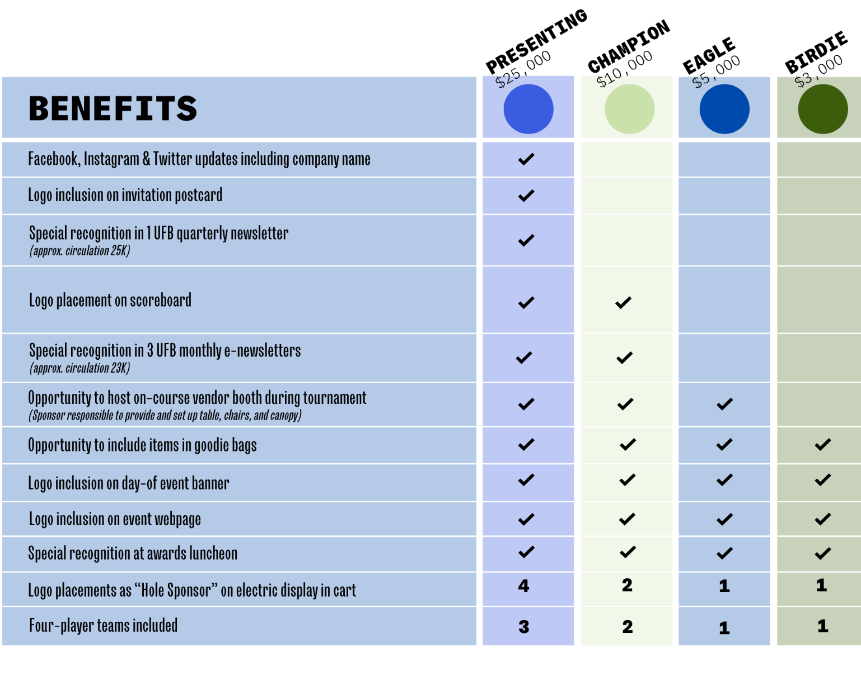

Contact Heidi Cannella at (801) 887-1278 or [heidic@utahfoodbank.org](mailto:heidic@utahfoodbank.org) with questions.

**SPONSORSHIP OPPORTUNITIES**

*Sponsorship deadline is September 5, 2025.*



**CORPORATE SPONSOR &**

**Team**

**TEAM REGISTRATION**

Please select your support level:

**$10,000 Champion $5,000 Eagle**

**$3,000 Birdie $1,200 Four-Player Team $600 Two-Player Team**

**Let’s call it a “mulligan”—I’m sleeping in this year, but still want to donate:** **$**_______________

Primary Contact Name______________________________________________________________________

Phone Number ______________________________Email_________________________________________

Name of Organization ______________________________________________________________________

Mailing Address ___________________________________________________________________________

City/State/Zip _____________________________________________________________________________

**PAYMENT OPTIONS**

Amount $___________________________________ Cash Check Credit Card

**Charge credit card**: VISA AMEX MasterCard Discover

Name as it appears on CC __________________________­­­­­­­_______________ Security Code _____________

CC # ___________________________________________________ Exp. Date _____ /_____ /___________

Billing Address____________________________________________________________________________

**Authorized Signature** ______________________________________________________________________

**Enclosed is a check payable to Utah Food Bank (Check #_______________________________)**

**Invoice Me**

Primary Contact Name______________________________________________________________________

Name of Organization ______________________________________________________________________

Mailing Address ___________________________________________________________________________

City/State/Zip _____________________________________________________________________________

***Please also complete team roster form on following page and return to:***

Utah Food Bank / Attn: Heidi Cannella / 3150 S 900 W, Salt Lake City, UT 84119

[heidic@UtahFoodBank.org](mailto:heidic@UtahFoodBank.org)

***Utah Food Bank is a private, non-profit, 501(c)(3) tax-exempt organization. Tax ID 87-0212453.***



TEAM ROSTER FORM

______________________________________ ______________________________________________

Primary Contact Name Team Name/Company Name

_______________________________________­­­­­­­­­­­­­­­­­­­­­___________________________________________________

Address (Including City, State & Zip Code)

_______________________________________ ________________________________________________

Phone Email

_______________________________________ ________________________________________________

Player One Phone & Email

________________________________________ ________________________________________________

Player Two Phone & Email

________________________________________ ________________________________________________

Player Three Phone & Email

________________________________________ ________________________________________________

Player Four Phone & Email





**RULES OF PLAY**

**SCRAMBLE**

* Gold tees for men and bronze for women.
* All players will hit their tee shot. Team players will drop a ball within one club length of that spot and play their second shots from that point. Continue this procedure until a ball is holed on the putting green. Record your team score on the card and proceed to the next hole. MAXIMUM SCORE ON A HOLE IS A PAR

**DRESS CODE** (strict adherence required for play)

* Denim and jeans are not permitted.
* No sweats, swimwear or athletic wear.
* Collared shirts only for men.

**ON THE COURSE**

* Beverages will be provided on-course clubhouse at holes 4,7, and 17.
* Please rake the sand traps, replace any divots, and repair your ball marks on the greens.

**PACE OF PLAY**

* Maximum possible score per hole is a double bogey. If you are putting for a double bogey, PLEASE PICK UP YOUR BALL AND MOVE ON.
* Please do not spend much time looking for golf balls (3-minute limit).
* Time limit for the round will be 5 hours. Should Course Marshall tell you to finish the play, you should score par for all unplayed holes.

**PRIZE HOLES**

* Hole-in-One Challenge (9)
* Closest to the Pin Men (11)
* Closest to the Pin Women (17)
* Longest Drive Men (13)
* Longest Drive Women (7)

**LOCATION**

Riverside Country Club

2701 N University Ave

Provo, UT 84604