

ANNOUNCEMENT

NOTICE OF INVITATION TO BID

FOR

GENERAL FOOD SERVICE FOODS AND SUPPLIES

Utah Food Bank invites written bids from qualified companies who wish to provide general food service foods and supplies starting July 1st , 2023 thru June 30th, 2024. Foods provided will be served as part of the USDA’s Child and Adult Care Food Program (CACFP), and Summer Food Service Program (SFSP). This bid has been divided up into 11 separate sections. The bid will be evaluated and awarded to the vendor with the lowest responsive aggregate price for each **section**. However, in the event no single vendor provides an acceptable item and pricing for **all** line items within a particular section, we will award for each line item individually based on lowest price for each of those items. Vendors are therefore encouraged to respond to all line items even if they do not carry all the products within each section. It is anticipated this ITB will result in multiple contract awards. Resulting contracts for awarded sections or items will be for one year with the possibility of renewal for four additional years.

The majority of items listed in the attached item list reflect the items/specifications provided by our current vendor and used in our daily production. Vendors are encouraged to provide pricing on equivalent items as approved equivalents may be accepted. Other pack sizes may also be accepted, but should be appropriate for high volume food service operations.

Three (3) copies of each respondent’s bid must be delivered to the above address. All bids must be returned in a sealed envelope not by email. Responses must be in sealed envelopes or containers, marked plainly and prominently as follows: “Bid Response for General Food Services and Supplies.” Late bids will NOT be considered under any circumstances and will be returned unopened. Respondent must sign bid.

Return sealed bids to:

Utah Food Bank

Attn: Matthew Anderson

3150 South 900 West Salt Lake City, UT 84119

Business Name: Phone: ( ) -

Address: City-State-Zip: Email Address: Signature: Print Name:

Bid Deadline: June23rd, 2023

Bid Closing: 5:00PM MST

Utah Food Bank hereinafter referred as “UFB.” Food Service Vendor/Contractor submitting proposal will be referred to as “vendor” or “vendor(s)”. The contract awarded will be a fixed price contract.

UFB officers, employees, or agents shall neither solicit nor accept gratuities, favors, or anything of monetary value from vendors, or potential vendors. To the extent permissible under State law, rules, or regulations, such standards shall provide for appropriate penalties, sanctions, or other disciplinary actions to be applied for violations of such standards.

# BACKGROUND OF REQUESTOR

* 1. UFB is the central collection and distribution hub for emergency and supplemental food for families and individuals in Utah experiencing the hardships of hunger and poverty. Donations of food and other useful household goods are distributed to Utahns in need through a statewide network of over 230 partner agencies including emergency food pantries, churches, senior centers and after-school programs. In 2022, Utah Food Bank distributed over 67 million pounds of food—the equivalent of over 56 million meals.
  2. UFB Kids Cafe program currently serves hot meals, thaw & serve meals, and shelf stable meals as part of the USDA’s Child and Adult Care Food Program and Summer Food Service Program. Last year we served more than 480,000 Kids Cafe meals. However, the food items and supplies under the scope of this ITB are primarily in support of the hot meal production that takes place at our Salt Lake based facility. We prepare approximately 1500 hot, nutritious meals each weekday. Last year we served more than 125,000 hot meals. Meals are set up and served by volunteers, site staff, and students at after-school programs in schools, community centers and other child-friendly locations.
  3. We will continue to look for growth opportunities, as our goal is to serve additional children struggling with food insecurity. We anticipate the opening of our Timpanogos kitchen facility that will greatly expand our ability to serve hot meals in Utah County and the surrounding area. That facility should be completed in December or January of this coming fiscal year. Therefore, we anticipating significant growth over the maximum length of this contract.

# PURPOSE OF REQUEST

* 1. The purpose of this solicitation is to enter into a fixed-priced contract with one or multiple vendors for general food services foods and supplies.
  2. It is anticipated this ITB will result in multiple contract awards. Resulting contracts for awarded sections or items will be for one year with the possibility of renewal for four additional years.
  3. The contract will be between the vendor and UFB. The successful vendor(s) shall be required to enter into a contract that incorporates this ITB, including all of its exhibits, as well as the vendor’s bid response. Significant general terms and conditions will include, but are not limited to those in this ITB.

# INSTRUCTIONS

* 1. Sealed bids will be received by UFB. In accordance with competitive contracting procedures, the proposals will be opened publicly. Proposals are due at 5:00 PM June 23rd 2023. Bids will be opened at 11:00 AM on June 26th, 2023.
  2. Proposals must be in sealed envelopes or containers, marked plainly and prominently as follows: “Bid Response for General Food Services and Supplies.” Return sealed proposal to:

Utah Food Bank

Attn: Matthew Anderson 3150 South 900 West Salt Lake City, UT 84119

* 1. It is the responsibility of vendor to ensure the bid is delivered by the time it is due. No late proposals will be accepted.
  2. UFB reserves the right to reject any and all bids and to waive any “informalities” in the bid responses received whenever such action, rejection, or waiver is in its best interests.
  3. No pleas of ignorance relating to any data encountered under this contract will be accepted as a result of failure or omission on the part of vendor to fulfill in every respect all the requirements, nor will the same be accepted as a basis for any claim whatsoever for extra charges for food services.
  4. Ensure the response package contains everything listed on Attachment G: Bid Packet Checklist.
  5. CACFP and SFSP Policy and general bid question Q&As- Send all questions to: [matta@utahfoodbank.org](mailto:matta@utahfoodbank.org). All Q&As can be viewed by following this link ([Utah Food Bank General Food Service Foods and Supplies ITB Q&A](https://utahfoodbank-my.sharepoint.com/:w:/g/personal/matta_utahfoodbank_org/EcNUwE46iTtInMRjHn9RH9QBklzVSEEXYEw3ar2oIou17A?e=EMeeYC) .

1. SELECTION CRITERIA:
   1. This bid has been divided up into 11 separate sections. The bid will be evaluated and awarded to the vendor with the lowest responsive aggregate price for each **section**. A vendor may be able to be awarded multiple sections. However, in the event no single vendor provides an acceptable item and pricing for **all** line items within a particular section, we will award for each line item individually based on lowest price for each of those items. Vendors are therefore encouraged to respond to all line items as outlined in Attachment E even if they do not carry all the products within each section. It is anticipated this ITB will result in multiple contract awards. Resulting contracts for awarded sections or items will be for one year with the possibility of renewal for four additional years.
   2. The final selection will be subject to review and approval by Utah Food Bank’s selection committee.
2. VENDOR EXPERIENCE AND QUALIFICATIONS:
   1. All vendors are requested to respond briefly to the following questions. Please limit the response to no more than one page per question.
   2. Qualifications and experience of management team.
      1. Briefly describe your organization's experience in planning and providing food items compliant with federal child nutrition programs.
      2. Provide details regarding company location(s) and staffing for activities relevant to this invitation.
      3. Include a list of any clients with which the vendor has contracted in this capacity during the past three years and indicate if the clients are still active clients.

# FOOD CREDITNG INFORMATION FOR FEDERAL CHILD NUTRITION PROGRAMS:

* 1. Vendor must provide detailed specifications for all food items listed in Attachment E. Specifications should include grade, purchase units, style, condition, weight, ingredients. Column H indicates which items require additional crediting information for the USDA’s child nutrition programs. These items require a Child Nutrition Label or complete Product Formulation Statement that meet USDA requirements. The supporting information should be sufficient for UFB to confirm the creditability and contribution of items toward the required meal pattern. Changes and substitutions to items may only be made with the approval of UFB. The proposed items must meet USDA guidelines for Food Based Menu Planning based as exhibited in the Final Rule 7 CFR 226 Child and Adult Care Food Program (published April 25, 2016). Documentation can be found by visiting: [https://www.gpo.gov/fdsys/pkg/FR-2016-04-25/pdf/2016-09412.pdf.](https://www.gpo.gov/fdsys/pkg/FR-2016-04-25/pdf/2016-09412.pdf) A summary of meal pattern requirements are outlined on Attachment C: CACFP Meal Pattern Chart (Ages 6-18)
  2. Grain items used to meet crediting requirements must be whole- grain rich. For more information on grain requirements refer to Attachment D: Exhibit A Grains Crediting Chart For Child Nutrition Programs. Breakfast items specifically identified for summer programs only can be made with enriched or whole grain flour.

1. ADDITIONAL REQUIRED CLAUSES
2. No payment will be made to the vendor for food items that are spoiled, unwholesome, substituted without prior approval and include required crediting documentation, or do not otherwise meet the requirements of the contract.
3. The vendor must have State or local health certification for the facility in which it proposes to store food items for use in the Program. It must ensure that health and sanitation requirements are met at all times.
4. Vendor must maintain records (supported by invoices, receipts, or other evidence) that the sponsor needs to meet Program responsibilities. The vendor must keep records concerning the contracted services for three years from the date of receipt of final payment under the contract. Representatives of the State agency, USDA, and the United States GAO may examine or audit these records at any reasonable time and place. Records must be retained longer if there is an unresolved audit or investigation.

# PRICE GUARENTEE PROVISION

* 1. Prices including shipping as provided during the bidding process will be guaranteed for the term of the contract.
  2. Price adjustments may be considered during the renewal option. All changes, either increase or decrease, must supported by corresponding data from a professionally recognized price index such as the Consumer Price Index for All Urban Consumers (CPI-U).

# OTHER PROVISIONS:

* 1. The vendor shall be paid by UFB for all items delivered in accordance with the contract and this part..
  2. Items shall be delivered in accordance with a delivery schedule prescribed in the contract.
  3. Increases and decreases in the number of items ordered shall be made by UFB, as needed, within a prior notice period mutually agreed upon.
  4. In cases on nonperformance or noncompliance on the part of the vendor, the vendor shall pay the UFB for any excess costs which the UFB may incur from the loss of eligible reimbursement under the USDA Federal Child Nutrition Programs.

# GENERAL CONTRACT TERMS AND CONDITIONS

* 1. The successful vendor shall enter into a contract to be mutually determined based on the specifications as outlined in the ITB and vendor response. Significant general contract terms and conditions will include, but are not limited to:
     1. Meeting Legal Requirements - The vendor will comply with all federal, state, and local laws.
     2. Review of Bids, Invoices, etc. - UFB reserves the right to review all bids, invoices, and any other pertinent records of the vendor at any time.
     3. Environmental: The vendor and UFB shall comply with all applicable standards, orders, or requirements issued under Section 306 of the Clean Air Act (42 USC 1857(h), Section 508 of the Clean Water Act (33 USC 1368), Executive Order 11738, and Environmental Protection Agency regulations (40 CFR Part 15), which prohibit the use under non-exempt federal contracts, grants or loans of facilities included on the EPA list of Violating Facilities. Violations shall be reported to the

U.S. Department of Agriculture and to the US EPA Assistant Administrator for Enforcement (EN-329).

* + 1. Energy: The vendor and UFB shall recognize mandatory standards and policies relating to energy efficiency which are contained in the State energy conservation plan issued in compliance with the Energy Policy and Conservation Act (7 CFR, Section 3016.36(i)(3).
    2. Equal Employment: The vendor and UFB shall comply with Executive Order 11246, entitled “Equal Employment Opportunity,” as amended by Executive Order 11375, and as supplemented in the Department of Labor regulations (41 CFR Part 60) pursuant to 7 CFR, Section 3016.(i)(3).
    3. Work Hours: The vendor and UFB shall comply with the Fair Labor Standards Act, as amended, to include Sections 103 and 107 of the Contract Work Hours and Safety Standards Act (40 USC 327- 330) as supplemented by Department of Labor regulations (29 CFR, Part 5) pursuant to 7 CFR, Section 3016.36(i)(6).
    4. Nondiscrimination: The vendor and UFB shall not discriminate on the basis of disability, race, color, sex, national origin or age as defined by applicable governmental law, in the recruitment, selection, training, utilization, promotion, termination, or other employment related activities concerning food service personnel pursuant but not limited to Titles VI and VII of the Civil Rights Act of 1964. This fundamental rule of conduct will be clearly communicated to all employees, prospective employees and the community at large. In addition, each part affirms that it is an equal opportunity and affirmative action employer.
    5. Drug-Free Workplace: The vendor shall comply with the Government-wide Requirements for a Drug- Free Workplace (DFW). The DFW requirements include making a good faith effort, on a continuing basis, to maintain a drug-free workplace. Those measures are to: 1) Publish a drug-free workplace statement and establish a drug-free awareness program for employees identified in 7 CFR 3021.205 through 3021-220; 2) Take actions concerning employees who are convicted of violating drug statutes in the workplace identified in 7 CFR 3021.225. The statement must be given to each employee who will be engaged in the performance of the contract and that statement must: a) Tell employees that the unlawful manufacturer, distribution, dispensing, possession, or use of a controlled substance is prohibited in the workplace, b) specify the actions that will be taken against employees for violating that prohibition and, c) inform each employee that, as a condition of employment under any award, he or she: 1) will abide by the terms of the statement and 2) must notify in writing if he or she is convicted for a violation of a criminal drug statute occurring in the workplace and must do so no more than five calendar days after the conviction.
  1. Licenses, Permits and Taxes
     1. The vendor will obtain and pay for all federal, state, and local licenses and permits required for the operations of the food service provided for herein and will collect and pay all sales, use, excise and state and local income taxes attributable to the food service provided for herein. The cost of all such items shall be a direct cost of operation.

ii. The vendor shall comply with all federal, state, and local laws and regulations governing the preparation, handling and serving of food, and shall obtain on behalf of UFB and keep in effect all licenses, permits, food handlers’ cards and health certifications as are required by law, and shall post such items in a prominent place within the food service areas as required.

# TERM, AND TERMINATION

* 1. The anticipated contract effective date will begin on July 1st, 2023, and terminate on June 30 th , 2024, unless an extension is agreed to by the vendor and UFB in accordance with the terms stated below, or unless terminated earlier as provided below.
  2. Any extensions of this contract shall be for a period of July 1st and ending June 30th . This contract is renewable four times (4) upon written agreement with both the vendor and UFB. Any such extensions shall not extend the contract period more than an additional four years beyond the original contract period.
  3. In the event either party breaches a provision of the contract, the non-defaulting party may terminate the contract for cause by giving sixty (60) days written notice. If the default is remedied prior to the proposed termination date, the non-defaulting party has the option of revoking said termination.
  4. UFB may terminate the contract for breach/neglect as determined by UFB with sixty (60) days written notice to the vendor, when considering such items as failure to maintain and enforce required standards of sanitation, failure to maintain proper insurance coverage as outlined by contract, failure to provide required periodic information/statements, or failure to maintain quality of service at a level satisfactory to UFB.
  5. The vendor and UFB may each terminate this contract without cause by providing sixty (60) days written notice to the other party of its intent not to renew the contract.
  6. The rights of termination referred to in this agreement are not intended to be exclusive and are in addition to any other rights available to either party at law or in equity.
  7. UFB’s financial commitments contained in the agreement are subject to annual appropriation by Utah Food Bank Board of Directors.
  8. Catastrophe- With the exception of payment obligations for prior performance under this agreement, neither the vendor nor UFB shall be liable for the failure to perform their respective obligations under this agreement when such failure is caused by fire, explosion, water, acts of God, civil disorder or disturbance, strikes, vandalism, war, riot, sabotage, governmental rules or regulations, or like causes beyond the reasonable control of such party, nor for real or personal property destroyed or damaged due to such causes.

1. AMENDMENTS TO CONTRACT –
   1. Any agreements shall remain in effect throughout its term unless the parties mutually agree, in a written document signed by both parties and attached to the agreement, to amend, add or delete any article or appendix. Any amendment to the agreement shall become effective at the time specified in any amendment. Comments from the vendor to UFB will go through UFB’s Contract Administrator.
2. CONTRACT ADMINISTRATOR
   1. UFB will name a person to represent them as a liaison between UFB and the successful vendor(s).

# ORDERING, DELIVERY, INVOICING

* 1. Items estimates reflect current service level and are subject to change. Changes to menus, food acceptability by students, or partner site participation can greatly change the number of items served per month. The item estimates provided are for bid purposes and should not be perceived by the vendor as a guarantee.
  2. Please provide information on any additional charges in Attachment E.
  3. All deliveries will be sent to the following location: 3150 S 900 W SLC, UT 84119. Once our Timpanogos Distribution Center is complete and operational deliveries will be made at that location as well. It is located at 855 South 1950 West Springville, UT 84663.
  4. Final price quote and receipt needs to be provided after orders are made.
  5. When responding to bid please include any discounts that may be available with early payment terms.
  6. After delivery has been made, product acceptability will be verified at the point of receiving before payment is made. Invoice will be provided to UFB on a monthly basis unless otherwise mutually agreed upon.

# BID ATTACHMENTS

Attachment A: Debarment Certification and Instructions (Vendor to Complete)

Attachment B: Certification Regarding Lobbying and Disclosure of Lobbying Activities (Vendor to complete) Attachment C: CACFP Meal Pattern Chart (Ages 6-18) (Reference)

Attachment D: Exhibit A: Grains Crediting Chart For Child Nutrition Programs (Reference)

Attachment E: Kids Cafe Food Service Item List for ITB FY2024 (Excel Workbook Download Vendor to Complete)

Attachment G: Bid Packet Checklist (Vendor to Complete)

Attachment A: Debarment Certification and Instructions (Vendor to Complete)

DEBARMENT & SUSPENSION: Contractor certifies that it is not presently nor has ever been debarred, suspended, proposed for debarment, or declared ineligible by any governmental department or agency, whether international, national, state, or local. Contractor must notify UFB within thirty (30) days if debarred, suspended, proposed for debarment, declared ineligible, or voluntarily excluded from participation in any contract by any governmental entity during this Contract.

PRINTED NAME POSITION

SIGNATURE DATE

Attachment B: Certification Regarding Lobbying and Disclosure of Lobbying Activities (Vendor to Complete)

# CERTIFICATION REGARDING LOBBYING

INSTRUCTIONS: To be completed and submitted ANNUALLY (1) any child nutrition entity receiving Federal reimbursement in excess of $100,000 per year and (2) potential or existing contractors/vendors as part of an original bid, contract renewal or extension when the contract exceeds $100,000.

**Applicable to Grants, Subgrants, Cooperative Agreements, and Contracts Exceeding $100,000 in Federal Funds**

Submission of this certification is a prerequisite for making or entering into this transaction and is imposed by section 1352, Title 31, U.S. Code. This certification is a material representation of fact upon which reliance was placed when this transaction was made or entered into. Any person who fails to file the required certification shall be subject to a civil penalty of not less than $10,000 and not more than $100,000 for each such failure.

The undersigned certifies, to the best of his or her knowledge and belief, that:

1. No federal appropriated funds have been paid or will be paid, by or on behalf of the undersigned, to any person for influencing or attempting to influence an officer or employee of an agency, a member of Congress, an officer or employee of Congress, or any employee of a member of Congress in connection with the awarding of any Federal contract, the making of any Federal grant, the making of any Federal loan, the entering into of any cooperative agreement, and the extension, continuation, renewal, amendment, or modification of any Federal contract, grant, loan, or cooperative agreement.
2. If any funds other than Federal appropriated funds have been paid or will be paid to any person for influencing or attempting to influence an officer or employee of any agency, a member of Congress, an officer or employee of Congress, or an employee of a member of Congress in connection with this Federal contract, grant, loan, or cooperative agreement, the undersigned shall complete and submit Standard Form-LLL, “Disclosure Form to Report Lobbying,” in accordance with its instructions.
3. The undersigned shall require that the language of this certification be included in the award documents for all covered subawards at all appropriate tiers (including subcontracts, subgrants, and contracts under grants, loans, and cooperative agreements) and that all subrecipients shall certify and disclose accordingly.

|  |  |  |
| --- | --- | --- |
| Name of Sponsor Receiving Child Nutrition Reimbursement in Excess of $100,000: Utah Food Bank | | Agreement Number: PB |
| Address of Sponsor: 3150 South 900 West Salt Lake City, UT 84119 | | |
| Printed Name and Title of Submitting Official: Matthew Anderson | Signature: | Date: |

or

|  |  |  |
| --- | --- | --- |
| Name of Food Service Management or Vendor: | | |
| Printed Name and Title: | Signature: | Date: |
| Name of Sponsor: Utah Food Bank | | Agreement Number: |

Attachment B: Certification Regarding Lobbying and Disclosure of Lobbying Activities (Vendor to Complete) cont.

INSTRUCTIONS FOR COMPLETION OF SF-LLL, DISCLOSURE OF LOBBYING ACTIVITIES

This disclosure form shall be completed by the reporting entity, whether subawardee or prime Federal recipient, at the initiation or receipt of a covered Federal action, or a material change to a previous filing, pursuant to title 31, USC

section 1352. The filing of a form is required for each payment of agreement to make payment to any lobbying entity for influencing or attempting to influence an officer or employee of any agency, a Member of Congress, an officer of employee of Congress, or an employee of a Member of Congress in connection with a covered Federal Action. Use the SF-LLL-A continuation Sheet for additional information if the space on the form is inadequate. Complete all items that apply for both the initial filing and material change report. Refer to the implementing guidance published by the Office of Management and Budget for additional information.

1. Identify the type of covered Federal action for which lobbying is and/or has been secured to influence the outcome of a covered Federal action.
2. Identify the status of the covered Federal action.
3. Identify the appropriate classification of this report. If this is a follow-up report caused by a material change to the information previously reported, enter the year and quarter in which the change occurred. Enter the date of the last previously submitted report by this reporting entity for this covered Federal action.
4. Enter the full name, address, city, state, and zip code of the reporting entity. Include Congressional UFB, if known. Check the appropriate classification of the reporting entity that designates if it is, or expects to be, a prime or subawarded recipient. Identify the tier of the subawardee, e.g., the first subawardee of the prime is the 1st tier. Subawards include, but are not limited to, subcontracts, subgrants, and contract awards under grants.
5. If the organization filing the report in item 4 checks "Subawardee," then enter the full name, address, city, state, and zip code of the prime Federal recipient. Include congressional UFB, if known.
6. Enter the name of the Federal agency making the award or loan commitment. Include at least one organizational level below agency name, if known. For example, Department of Transportation, United States Coast Guard.
7. Enter the Federal program name of description for the covered Federal action (item 1). If known, enter the full Catalog of Federal Domestic Assistance (CFDA) number for grants, cooperative agreements, loans, and loan commitments.
8. Enter the most appropriate Federal identifying number available for the Federal action identified in item 1 (e.g., Request for Proposal (RFP) number; Invitation for Bid (IFB) number; grant announcement number; the contract, grant, or loan award number; the application/proposal control number assigned by the Federal agency). Include prefixes, e.g., "RFP-DE-90-001."
9. For covered Federal action where there has been an award or loan commitment by the Federal agency, enter the Federal amount of the award/loan commitment for the prime entity identify in item 4 or 5.
10. (a) Enter the full name, address, city, state, and zip code of the lobbying entity engaged by the reporting entity identified in item 4 to influence the covered Federal action.

(b) Enter the full names of the individual(s) performing services, and include full address if different from 10(a). Enter last name, first name, and middle initial.

1. Enter the amount of compensation paid or reasonably expected to be paid by the reporting entity (item 4) to the lobbying entity (item 10). Indicate whether the payment has been made (actual) or will be made (planned). Check all boxes that apply. If this is a material change report, enter the cumulative amount of payment made or planned to be made.
2. Check the appropriate box(es). Check all boxes that apply. If payment is made through an in-kind contribution, specify the nature and value of the in-kind payment.
3. Check the appropriate box(es). Check all boxes that apply. If other, specify nature.
4. Provide a specific and detailed description of the services that the lobbyist has performed, or will be expected to perform, and the date(s) of any services rendered. Include all preparatory and related activity, not just time spent in actual contact with Federal officials. Identify the Federal official(s) or employee(s) contacted or the officer(s), employee(s), or Member(s) of Congress that were contacted.
5. Check whether or not a SF-LLL-A Continuation Sheet(s) is attached.
6. The certifying official shall sign and date the form, print his/her name, title, and telephone number.

Public reporting burden for this collection of information is estimated to average 30 minutes per response, including time for reviewing instructions, searching existing data sources, gathering and maintaining the data needed, and completing and reviewing the collection of information. Send comments regarding the burden estimates or any other aspect of this collection of information, including suggestions for reducing this burden, to the Office of Management and Budget, Paperwork Reduction Project (03-48-0046), Washington, D.C. 20503.

Attachment B: Certification Regarding Lobbying and Disclosure of Lobbying Activities (Vendor to Complete) cont.

**DISCLOSURE OF LOBBYING ACTIVITIES** Approved by OMB

Complete this form to disclose lobbying activities pursuant to 31 USC 1352

(See reverse for public burden disclosure) 0348-0046

|  |  |  |  |  |  |  |  |  |
| --- | --- | --- | --- | --- | --- | --- | --- | --- |
| 1. **Type of Federal Action**:    1. Contract    2. Grant    3. Cooperative agreements    4. Loan    5. Loan guarantee    6. Loan insurance | | 2. **Status of Federal Action**:   1. Bid/offer/application 2. Initial award 3. Post-award | | | | | 1. **Report Type**:    1. Initial filing    2. Material change   **FOR MATERIAL CHANGE ONLY**:  Year Quarter | |
| [ | 4. **Name and Address of Reporting Entry**:  ] Subawardee  Tier , if known  Congressional UFB, if known*:* | |  |  | 5. **If Reporting Entry in No. 4 is Subawardee, Enter Name and Address of Prime**:  Congressional UFB, if known*:* | | | |
| 6. **Federal Department/Agency**: | | | | | 7. **Federal Program Name Description**:  CFDA Number, if applicable: | | | |
| 8. **Federal Action Number, if known:** | | | | | 9. **Award Amount**, **if known:** | | | |
| 10a. **Name and Address of Lobbying Entity**  (if individual, last name, first name, MI): | | | | | 10b. **Individuals Performing Services** (including address if different from No. 10a.)  (last name, first name, MI): | | | |
| (attach Continuation Sheet(s) SF-LLL-A, if necessary) | | | | | | | | |
|  | 11. **Amount of Payment** (check all that apply):  $ [ ] actual [ | | ] planned |  | 12. **Type of Payment** (check all that apply): [ ] a. Retainer  [ ] b. One-time fee [ ] c. Commission  [ ] d. Contingent fee [ ] e. Deferred  [ ] f. Other, specify | | | |
| 13. **Form of Payment** (check all that apply*)*: [ ] a. Cash  [ ] b. In-kind, specify: Nature Value | | | | |
| 14. **Brief Description of Services Performed or to be Performed and Date(s) of Service, including officer(s), employee(s), or member(s) contacted for payment indicated in No. 11:**  (attach Continuation Sheet(s) SF-LLL-A, if necessary) | | | | | | | | |
|  | 15. **Continuation Sheet(s) SF-LLL-A attached:** | |  | **[ ] Yes** | | **[ ] No** |  |  |
| 16. Information required through this form is authorized by code 31 USC section 1352. This disclosure of lobbying activities is a material representation of fact upon which evidence was placed by the tier above when this transaction was made or entered into. This disclosure is required pursuant to 31 USC 1352. This information will be reported to the Congress semi-annually and will be available for public inspection. Any person who fails to file the required disclosure  shall be subject to a civil penalty of not less than $10,000.00 and not more than $100,000.00 for each such failure. | | | | | Signature:  Print Name:  Title:  Telephone No: ( ) Date: | | | |
| **Federal Use Only:** | | | | | | | | Authorized for Local Reproduction - Standard Form - LLL |

Attachment C: [CACFP Meal Pattern Chart](https://usbe.instructure.com/courses/405/files/41140/download?wrap=1) (Ages 6-18)

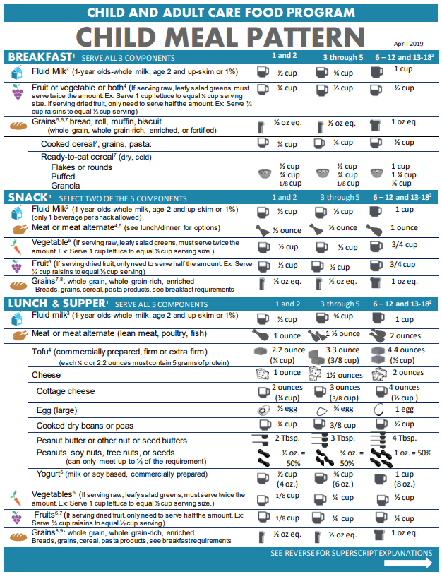

Attachment C: CACFP Meal Pattern Chart cont.

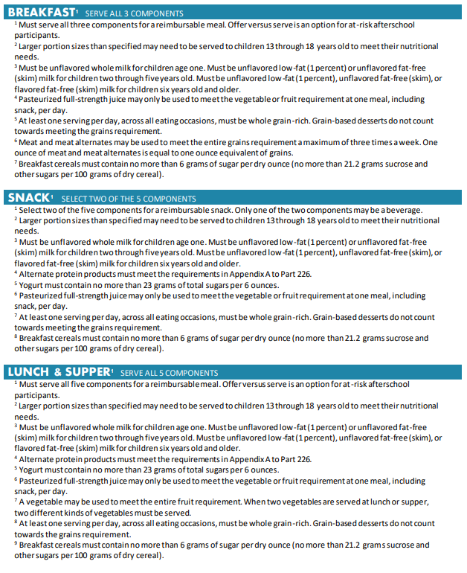

Attachment D: Exhibit A: [Grains Crediting Chart For Child Nutrition Programs](https://usbe.instructure.com/courses/405/files/41151/download?wrap=1)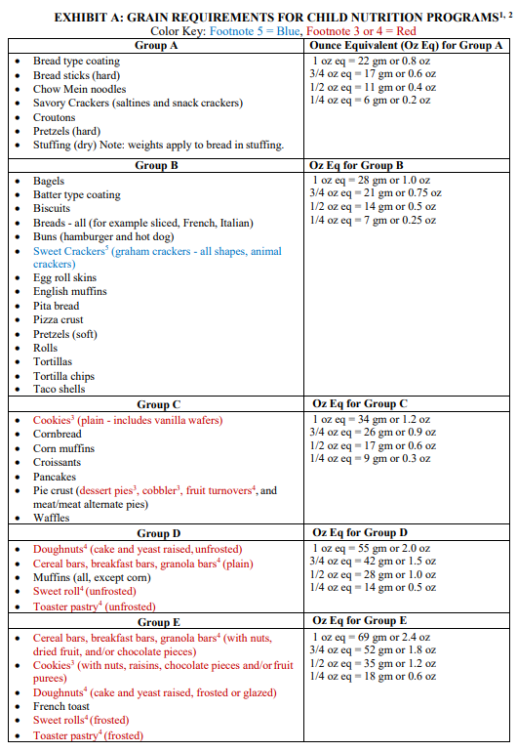

Attachment D: Exhibit A: Grains Crediting Chart For Child Nutrition Programs cont.

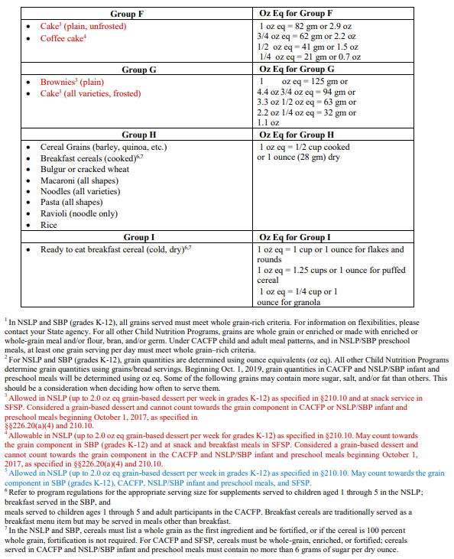

Attachment E: Kids Cafe Food Service Item List for ITB FY2024 (Excel Workbook Download)

Attachment G: Bid Packet Checklist (Vendor and UFB Scoring Staff to Complete)

Vendor will complete the first portion of this checklist (items 1-8). This same checklist format will be used by bid evaluation committee members to ensure each bid response contains all of the requested items and is complete. Incomplete bid packets will disqualify the vendor for consideration.

Vendor Name:

|  |  |  |  |
| --- | --- | --- | --- |
| **Item #** | **Required Item/Information** | **Item Submitted (yes/no)** | **Comment** |
| 1. | Completed Attachment A: Debarment Certification |  |  |
| 2. | Completed Attachment B: Certification Regarding Lobbying and Disclosure of Lobbying Activities |  |  |
| 3. | 3 copies of Bid Packet submitted on time, in sealed envelope, marked correctly. |  |  |
| 4. | Responded to each question regarding company location(s), number of staff,  and background, relevant experience. |  |  |
| 5. | Items include specification information (grade, purchase units, condition, weight, ingredients) |  |  |
| 6. | All items as indicated in column H have are creditable on the CACFP or SFSP Program (breakfast items only), and have complete supporting documentation. |  |  |
| 7. | Items meet minimum requirements as listed in the product specification (e.g. Fruits and juices are 100%, MMA and Grains meet minimum crediting). |  |  |
| 8. | Prices per applicable purchase unit have been included. Any additional delivery or fuel surcharge fees have been identified. |  |  |

Completed by (Full Name): Date:

**Section Aggregate Pricing Summary (UFB to Complete)**

|  |  |  |  |  |  |
| --- | --- | --- | --- | --- | --- |
| Section | Pricing | Partial Award Y/N, Item #s | Section | Pricing | Partial Award Y/N, Item #s |
| Bid Pricing Section 1 |  |  | Bid Response 7 Score: |  |  |
| Bid Pricing Section 2 |  |  | Bid Response 8 Score: |  |  |
| Bid Pricing Section 3 |  |  | Bid Response 9 Score: |  |  |
| Bid Pricing Section 4 |  |  | Bid Response 10 |  |  |
| Bid Pricing Section 5 |  |  | Bid Response 11: |  |  |
| Bid Pricing Section 6 |  |  |  |  |  |

Winning Bid Sections or Items Awarded#: _______________________________________________________________